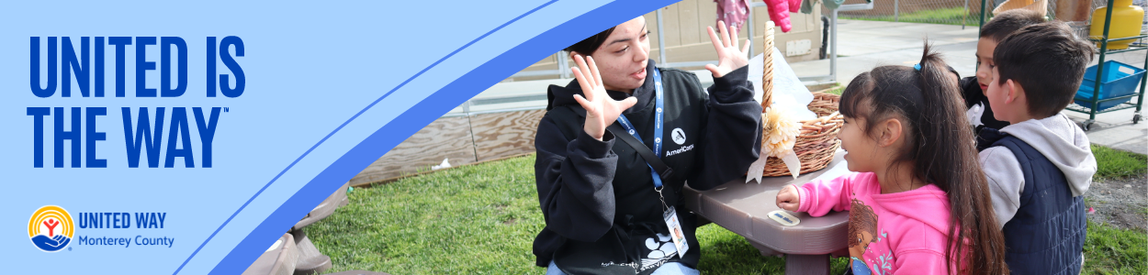
2025 CAMPAIGN TOOL KIT
Theme: United is the Way
ORGANIZATION NAME

CONTENTS:
Campaign Details
Sample Emails
Sample Social Media or Intranet Posts
Important Campaign Links

CAMPAIGN DETAILS
How long does the campaign last?
CAMPAIGN DATES AND GOAL (IF APPLICABLE) HERE
Which organizations are eligible for donations?
Through the giving campaign, you can donate to United Way Monterey County or any valid 501 (c) (3) nonprofit organization. You can search GuideStar to find a full list of 501 (c) (3) nonprofits.
How do I donate?
Contact your organization’s representative.

SAMPLE EMAILS
Communication is the key to a successful giving campaign! Use these sample emails to share United Way Monterey County’s impact and motivate your colleagues to participate in your campaign. Feel free to adapt these communications to fit your team and company culture. Contact Crystal Lopez, Community Relationship Manager, with any questions. We are here to help!

EMAIL TOPIC | ONE MONTH CAMPAIGN
Pre-Campaign Reminder | Week before Launch
Campaign Kick-off | Campaign Start Day
The Real Cost Measure in Monterey County | Week 1
Mid-point Update | Week 2
Story/Impact Highlight | Week 3
Final Week Email 1-Urgency and Momentum | Week 4 Email 1
Final Week Email 2- Choice + Celebration | Week 4 Email 2
Final Week Email 3- Countdown/Last Call | Week 4 Email 3
Post-Campaign Recap/Thank You Email | Final Thank You

PRE-CAMPAIGN REMINDER
Subject Line: Coming soon: United is the Way at Your Organization
Dear [EMPLOYEE NAME],
YOUR ORGANIZATION’s United Way Monterey County Giving Campaign kicks off next week! We are excited to unite as an organization to help people across Monterey County thrive.
Your support is needed now more than ever - Nearly 1 in 2 households can’t cover essentials like housing, food, and childcare. The high cost of living means even full-time work often times isn’t enough.
United is the Way forward – a way to lift our neighbors, strengthen our community, and build a better tomorrow. United Way invests in what matters most: kindergarten readiness, financial stability, and community resources that move us closer to a thriving, united community where everyone can succeed
Because when kids get a strong start, families are stable, and communities are healthy, we all benefit.
Be on the lookout for upcoming emails with more information about how you can participate in this year’s United Way Campaign!
With gratitude,
[Employee Campaign Manager name or 2025 volunteer campaign team names]

Campaign Kickoff
Subject: We are UNITED for Monterey County!
Welcome To YOUR ORGANIZATION’S 2025 United Way Monterey County Giving Campaign! United Way Monterey County connects people, partners, and pathways to improve lives across Monterey County. With deep local roots, they bring people and resources together to tackle our community’s greatest challenges - lack of affordable childcare, financial insecurity, and barriers to stable housing and essential services.
In 2024, United Way Monterey County:
- Filed 1,465 tax returns, putting $2.47M back into families’ pockets through our Volunteer Income Tax Assistance (VITA) program
- Facilitated 18,753 referrals for resources through 211 Monterey County.

- Provided language and literacy support to promote kindergarten readiness through our Monterey County Preschool Service Corps Program.
- Stuffed over 6,500 backpacks with grade-level school supplies to students experiencing homelessness
Your support allows United Way to strengthen resilience and expand youth opportunity, increase financial security, and connect families to essential resources.
Because United is the Way—to show up, to make a difference, and to build a stronger Monterey County.
Make a Donation
Thank you for helping kids get a strong start, families thrive—not just survive, and all Monterey County residents live longer, better lives.
[Employee Campaign Manager name or 2025 volunteer campaign team names]

The Real Cost Measure in Monterey County
Subject: 45% of Local Families Struggle to Cover Housing, Child Care, and Food
Every day in Monterey County, 45% of working households struggle to stay afloat. They don’t make the minimum amount of income required to meet basic needs including the cost of housing, childcare, food, transportation, health care, and taxes.
They are our childcare providers, health aids, delivery drivers, and retail workers — neighbors we rely on. You may have seen them today when you dropped off your child at childcare. You filled your gas tank. You grabbed your morning coffee. You received a package outside your door.
They’re here. Keeping our community running smoothly. They may be your friends and family.
At United Way Monterey County, we are laser-focused on helping households not just stay afloat but rise. Through strategic investments, local partnerships, public policy, programming, and volunteer work, we’re working every day to build a stronger, thriving Monterey County – for everyone.
United is the Way — to come together, to lift up families, and to create lasting change.
Your support of United Way Monterey County makes this possible. Can we count on your support to help more families reach stable ground?
[GIVE NOW]

Mid-Point Update
[Subject Line]: Still time to give back to what matters most.
We are halfway through our United Way Monterey County Giving Campaign. Together, we have raised [TOTAL RAISED] towards our goal of $150,000.
If you already made a pledge—thank you. We are so grateful for your support!
What makes this campaign unique is the power of choice. Through your Giving campaign, you can direct your gift to the causes that matter most to you — whether that’s supporting families and youth, protecting animals, or preserving our local environment.
This is more than fundraising. It’s about coming together as a community and believing in the power of giving back. Every gift, no matter where it goes, strengthens the fabric of Monterey County and helps create a brighter future for us all.
When we each give what we can to the causes closest to our hearts, we show what’s possible when generosity meets community. That’s the spirit of philanthropy — and the heart of this campaign.
Set Up Payroll Deductions!
[Employee Campaign Manager name or 2025 volunteer campaign team]

Story/Impact Highlight
[Subject Line]: One story. Countless ripples.
Every gift tells a story. Behind every pledge is a neighbor whose life is changed for the better.
Take Edith, for example. She’s a Family, Friends, and Neighbors (FFN) caregiver who attends United Way’s playgroups and monthly workshops. Edith says she always feels welcomed and supported, and that there’s always something new to learn.
Through the program, she’s discovered the value of open-ended activities and that the process is more important than the product. Before joining, she often pushed her granddaughter to complete activities in a certain way. Now, she gives her the time and space to explore — and has seen her granddaughter grow and thrive. Edith also shared that before participating, her granddaughter had very limited interaction with other children. Thanks to the playgroups, she now has the chance to connect with peers while Edith continues learning new ways to support her development.
When you give, you don’t just donate to a program — you create ripples of opportunity, stability, and hope across our community.
Your story of giving can be the next chapter in this campaign. Together, we can ensure more families thrive, more students succeed, and more neighbors find support when they need it most.
[Set Up Payroll Deductions]
Because United is the Way — to give, to care, and to create lasting change.
With gratitude,
[Employee Campaign Manager name or 2025 volunteer campaign team]

Final Week Email 1 – Urgency & Momentum
[Subject Line]: We’re close to our goal — but we need you.
United Way Monterey County’s Giving Campaign is in its final stretch — and together we’ve already raised [TOTAL RAISED] toward our [GOAL]! Thank you to everyone who has pledged so far.
But we’re not there yet. Every pledge matters, and yours could be the one that helps push us across the finish line.
Join the hundreds of your colleagues who have already given back. Together, we can show the power of our community when generosity meets action.
There’s still time to make your pledge — but don’t wait. The campaign closes soon!
[Make Your Pledge Today]
Because United is the Way — to show up, to make a difference, and to finish strong.
With gratitude,
[Employee Campaign Manager name or 2025 volunteer campaign team]

Final Week Email 2 – Choice + Celebration
[Subject Line]: Give where your heart is.
One of the most powerful parts of United Way Monterey County’s Giving Campaign is choice. You decide where your donation goes — to the causes and organizations that matter most to you.
Whether it’s helping families and youth, protecting animals, preserving the environment, or supporting United Way’s impact areas, your pledge ensures that Monterey County is stronger, healthier, and more resilient.
It’s not about how much you give, but the act of giving itself — the belief that together we can create real change.
There’s still time to pledge. Let your gift reflect your values and your vision for a thriving community.
[Set Up Payroll Deductions]
Because United is the Way — to care deeply, give freely, and strengthen what matters most.
With gratitude,
[Employee Campaign Manager name or 2025 volunteer campaign team]

Final Week Email 3 – Countdown/Last Call
[Subject Line]: One day left to make a difference.
This is the final day to be part of United Way Monterey County’s 2025 Giving Campaign!
If you haven’t made your pledge yet, now is the time. Your gift, no matter the size, helps build a community where children are ready for school, families are financially stable, and neighbors can access the resources they need.
Together, we’ve already raised [TOTAL RAISED], and we’re so close to reaching our $150,000 goal. Will you help us finish strong?
[Make Your Pledge Today]
Because United is the Way — to come together, to care for our neighbors, and to create lasting change.
With gratitude,
[Employee Campaign Manager name or 2025 volunteer campaign team]

Recap/Thank You Email
[Subject Line]: Together, we did it!
Thank you, Your Organization!
Because of your generosity, this year’s Giving Campaign raised [FINAL TOTAL RAISED] for Monterey County. Your gifts will support families, youth, animals, the environment, and vital community resources across our region.
When we each gave what we could, we proved the power of coming together. The collective impact of your generosity will be felt for years to come — in classrooms, in homes, in neighborhoods, and in every corner of our community.
This is what philanthropy looks like. This is what it means to live united.
From all of us at United Way Monterey County — and on behalf of the many nonprofits and families you’ve supported — thank you.
Because United is the Way — to give, to care, and to create lasting change.
With gratitude,
[Employee Campaign Manager name or 2025 volunteer campaign team]

SAMPLE SOCIAL MEDIA OR INTRANET POSTS
Spread the word through the organization intranet or on your social media channels!
Subject | Message | Photo
Pre-Campaign Reminder Post | Coming soon: Your Organization’s 2025 Giving Campaign with United Way Monterey County!  Nearly 1 in 2 households here can’t afford basic needs like housing, childcare, and food. Together, we can change that.  Stay tuned for how YOU can make an impact.  #UnitedIsTheWay #MontageHealth #UWMC | 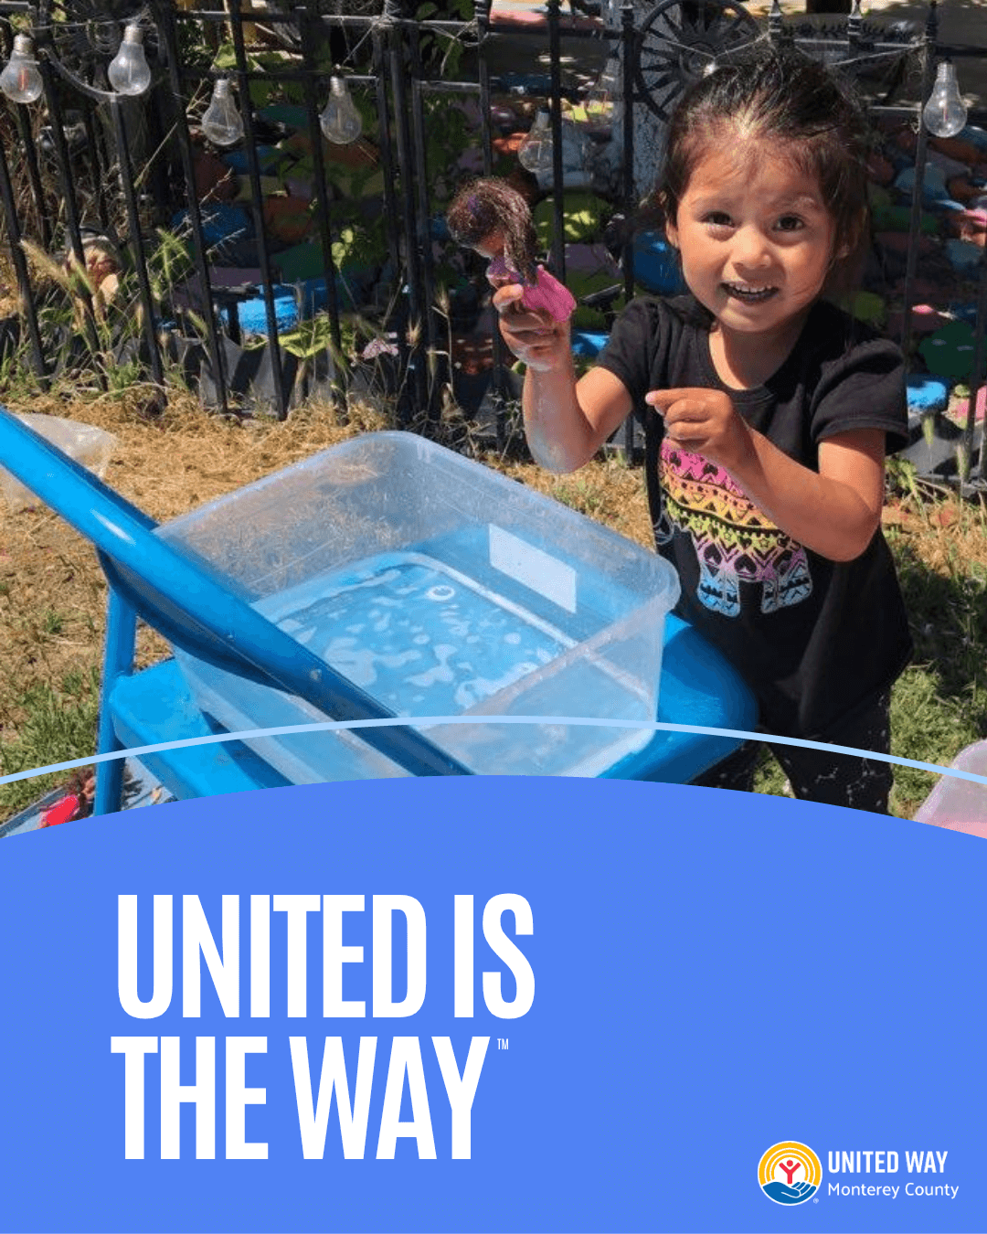
Campaign Kickoff Post | We’re officially kicking off Your Organization’s Giving Campaign with United Way Monterey County!  Last year, together we:  - Supported kindergarten readiness  - Helped families file 1,465 tax returns = $2.47M back in pockets  - Gave 6,500+ backpacks to students in need  - Connected nearly 19,000 people to resources through 211  This year let’s do even more. Because United is the Way to show up and make a difference.  #UnitedIsTheWay #MontageHealth #UWMC | 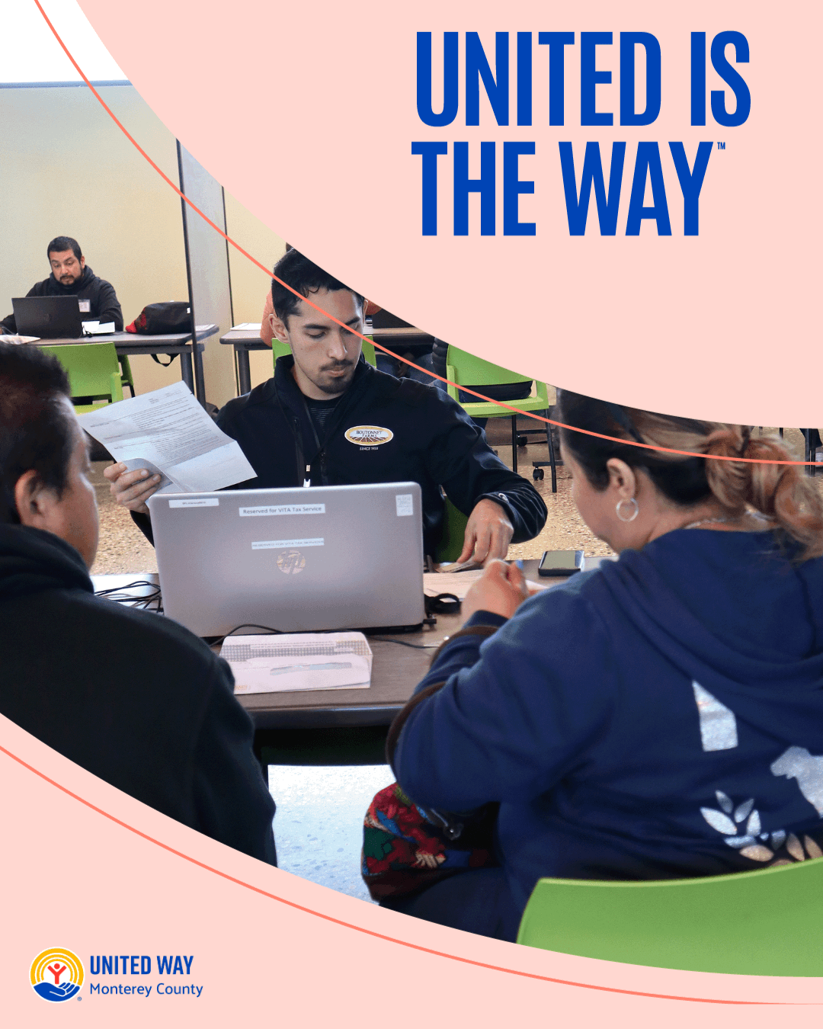
Real Cost Measure Post | Did you know? 45% of households in Monterey County can’t afford necessities like housing, food, and childcare — even when working full-time.  They’re our neighbors, coworkers, caregivers, and friends. And together, we can help more families reach stable ground.  Join us in building a stronger, thriving community.  #UnitedIsTheWay #MontageHealth #UWMC | 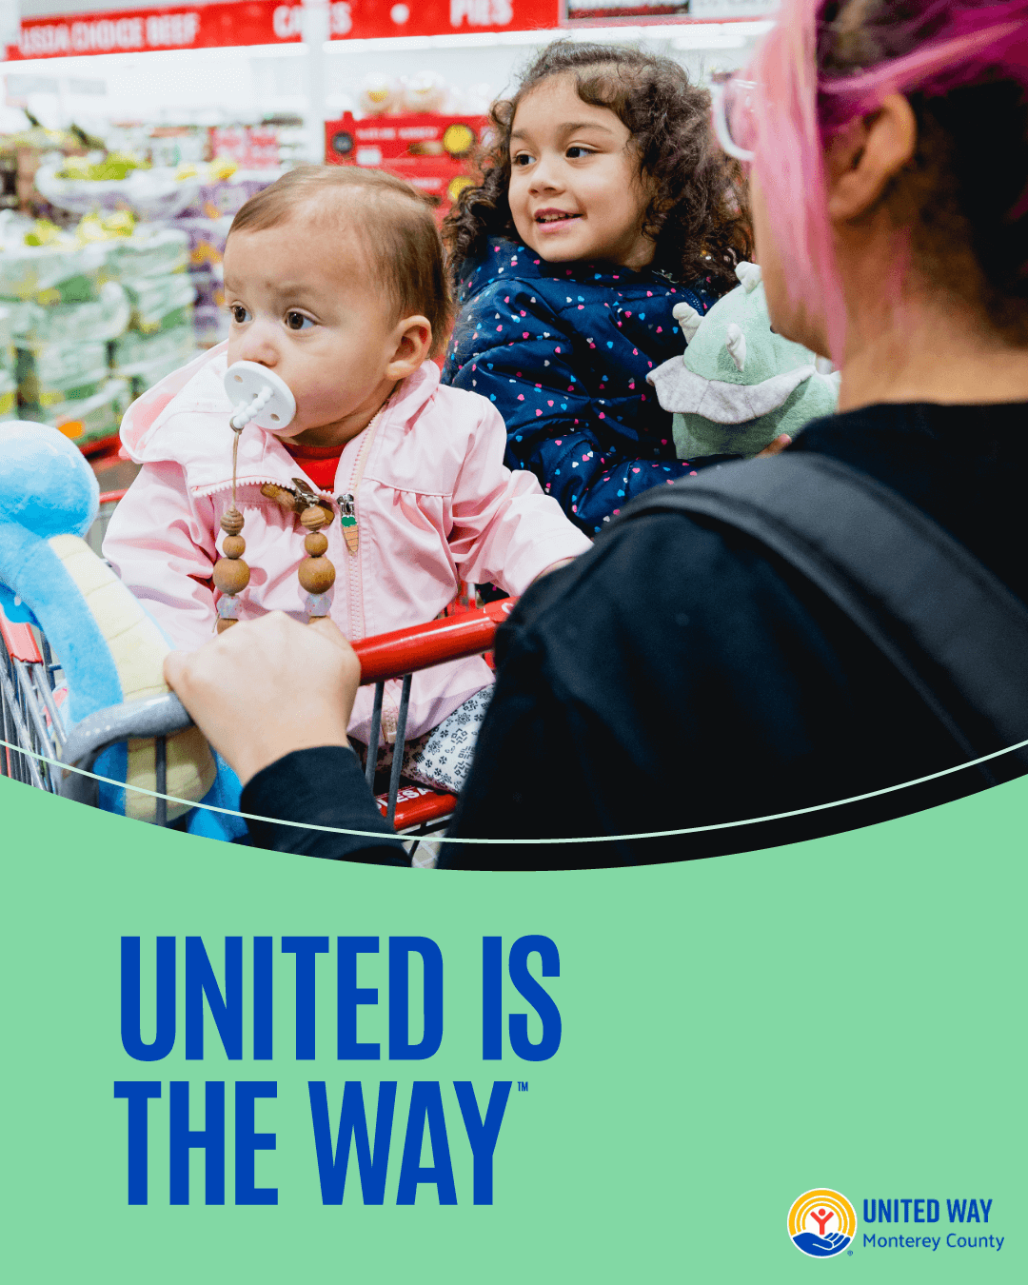
Mid-Point Update Post | We’re halfway through Your Organization’s Giving Campaign!  What makes this campaign powerful?  Choice. You can direct your gift to the causes that matter most to you — whether that’s families, youth, animals, or the environment.  There’s still time to give back. Set up your payroll deduction today and make a difference where it matters most.  #UnitedIsTheWay #MontageHealth #UWMC | 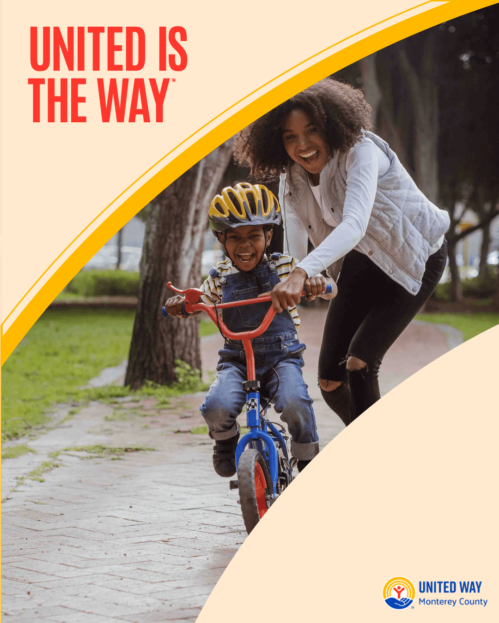
Story/Impact Highlight Post | Every gift tells a story. Meet Edith, a caregiver in our Family, Friends, and Neighbors Program.  Through playgroups and workshops, Edith has learned that the process is more important than the product — giving her granddaughter space to learn, explore, and connect with other kids.  This is the ripple effect of giving. Your pledge makes stories like Edith’s possible.  #UnitedIsTheWay #MontageHealth #UWMC | 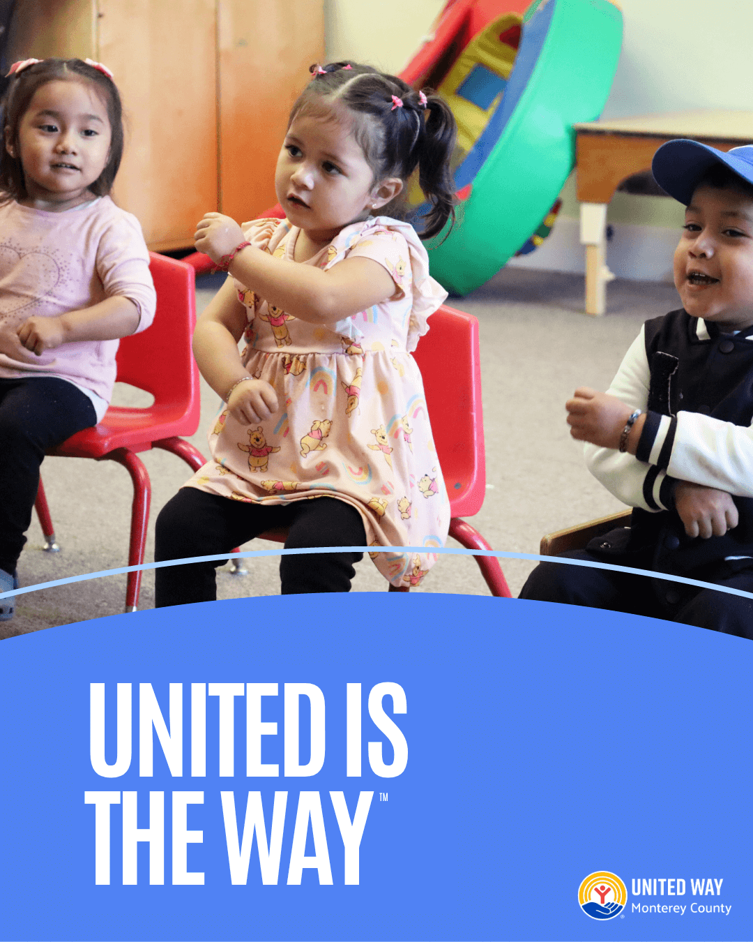
Final Week Email 1 Post | We’re in the final stretch!  But we’re not there yet — and your pledge could be the one that helps us finish strong.  Join your colleagues in giving back. Together, we’re proving that United is the Way to build a stronger community.  #UnitedIsTheWay #MontageHealth #UWMC | 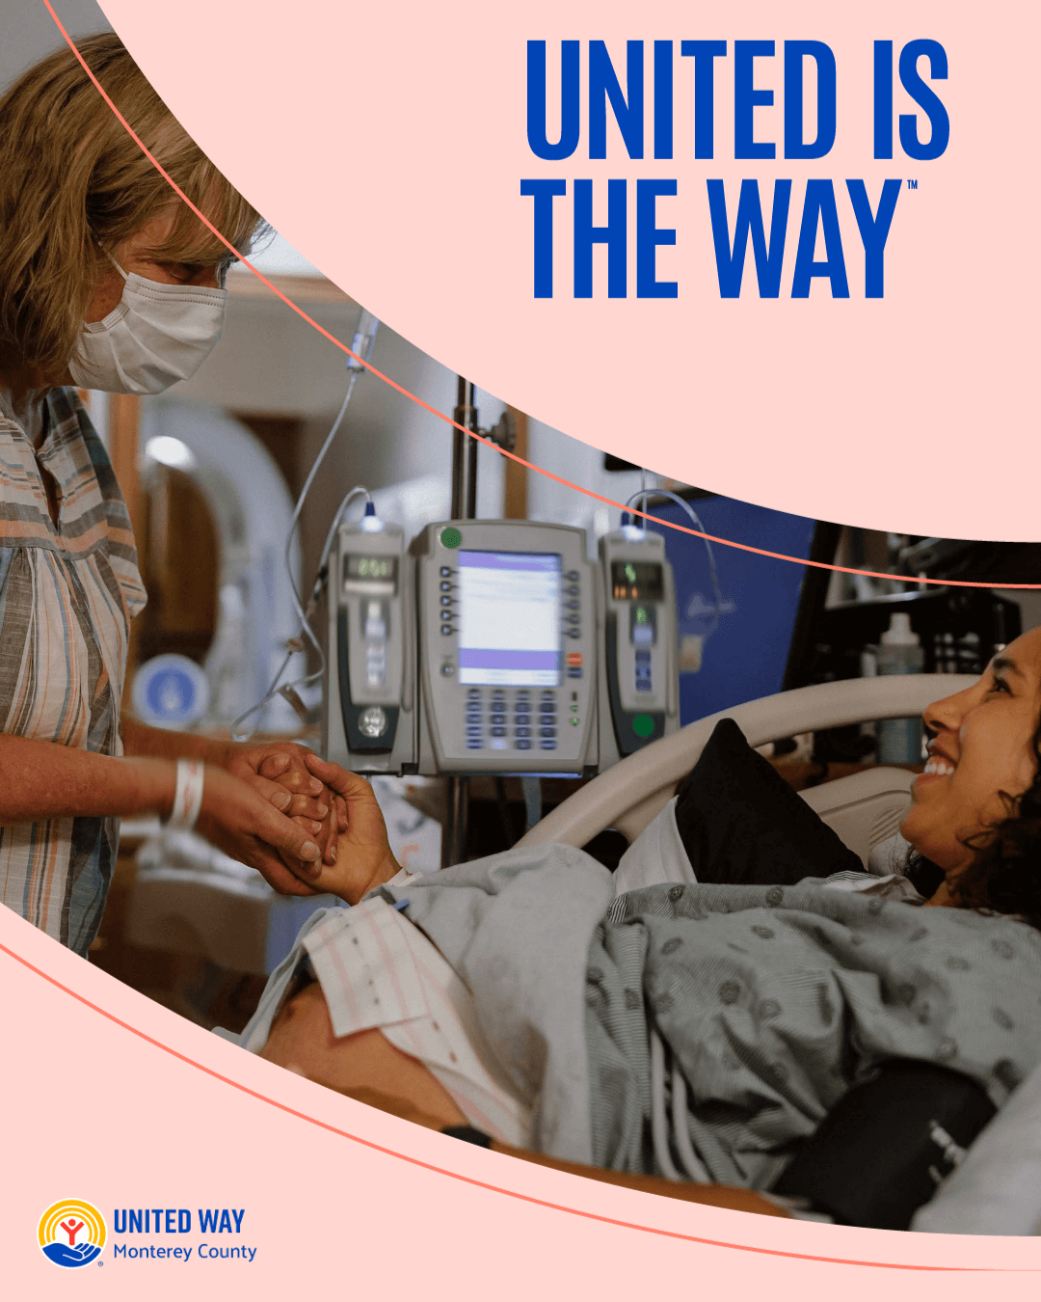
Final Week Email 2 Post | One campaign. Endless possibilities.  Through Your Organization’s Giving Campaign, you can direct your pledge to what matters most to you:  - Families & youth  - Animals  - The environment  - United Way’s impact areas  It’s your gift, your choice, your community. Let’s make it count.  #UnitedIsTheWay #MontageHealth #UWMC | 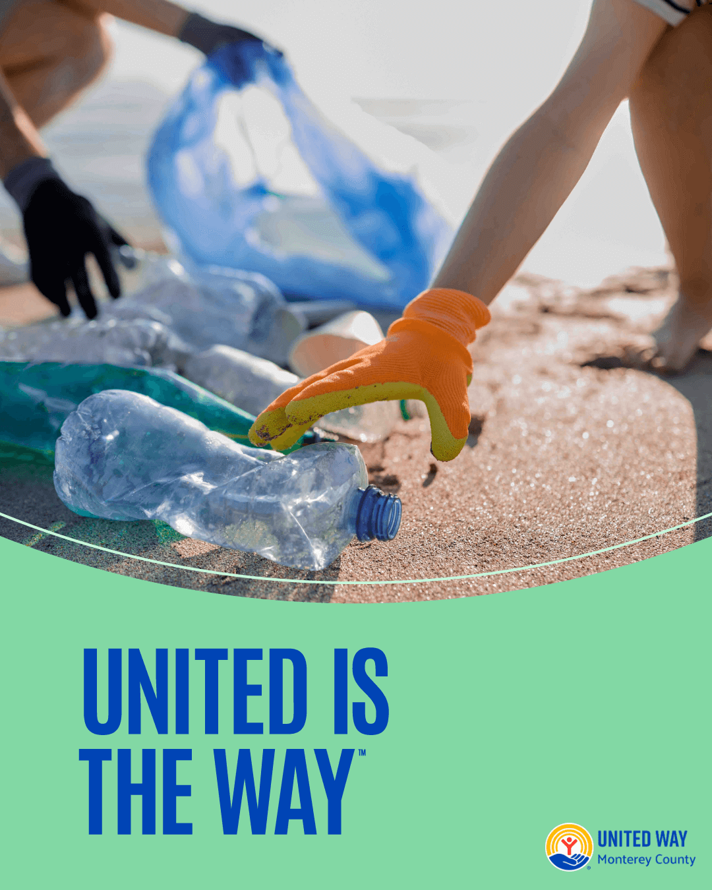
Final Week Email 3 Post | Last chance! Today is the final day to be part of Your Organization’s Giving Campaign.  Your pledge helps children thrive, families succeed, and neighbors get the resources they need.  Don’t miss your chance to make a difference.  #UnitedIsTheWay #MontageHealth #UWMC | 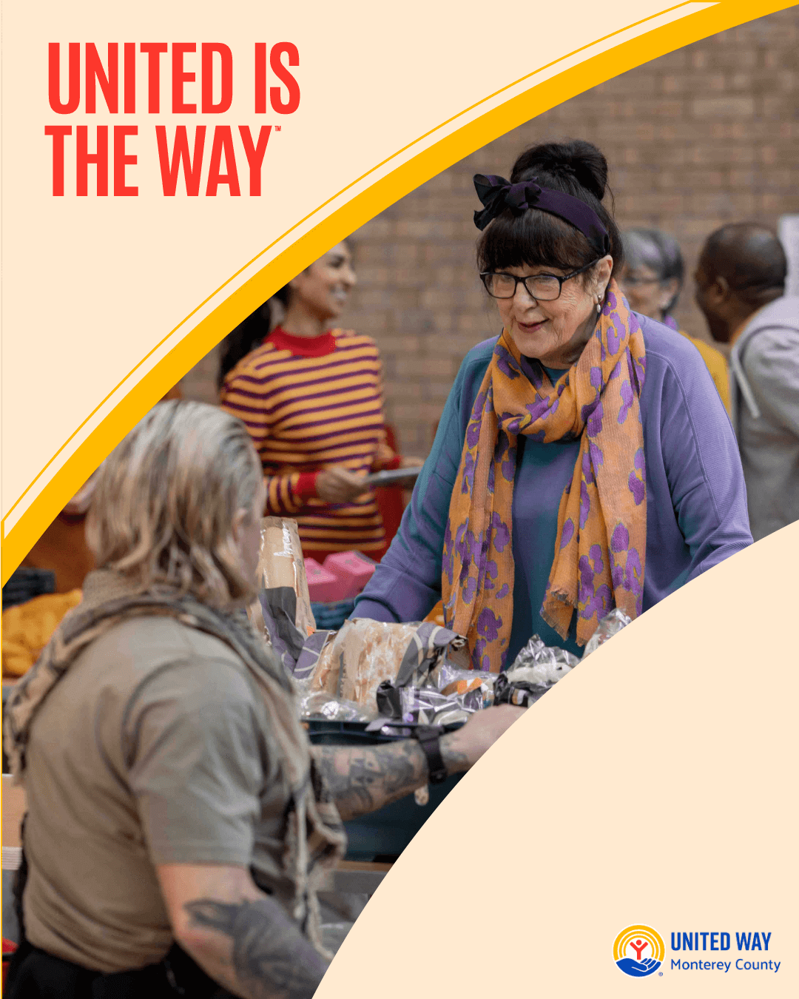
Recap/Thank You Post | Thank you, Your Organization!  Because of your generosity, this year’s Giving Campaign raised [FINAL TOTAL RAISED] for Monterey County. Together, you’ve supported families, youth, animals, the environment, and vital community programs.  This is what philanthropy looks like. This is what it means to live united. 💙  #UnitedIsTheWay #MontageHealth #UWMC | 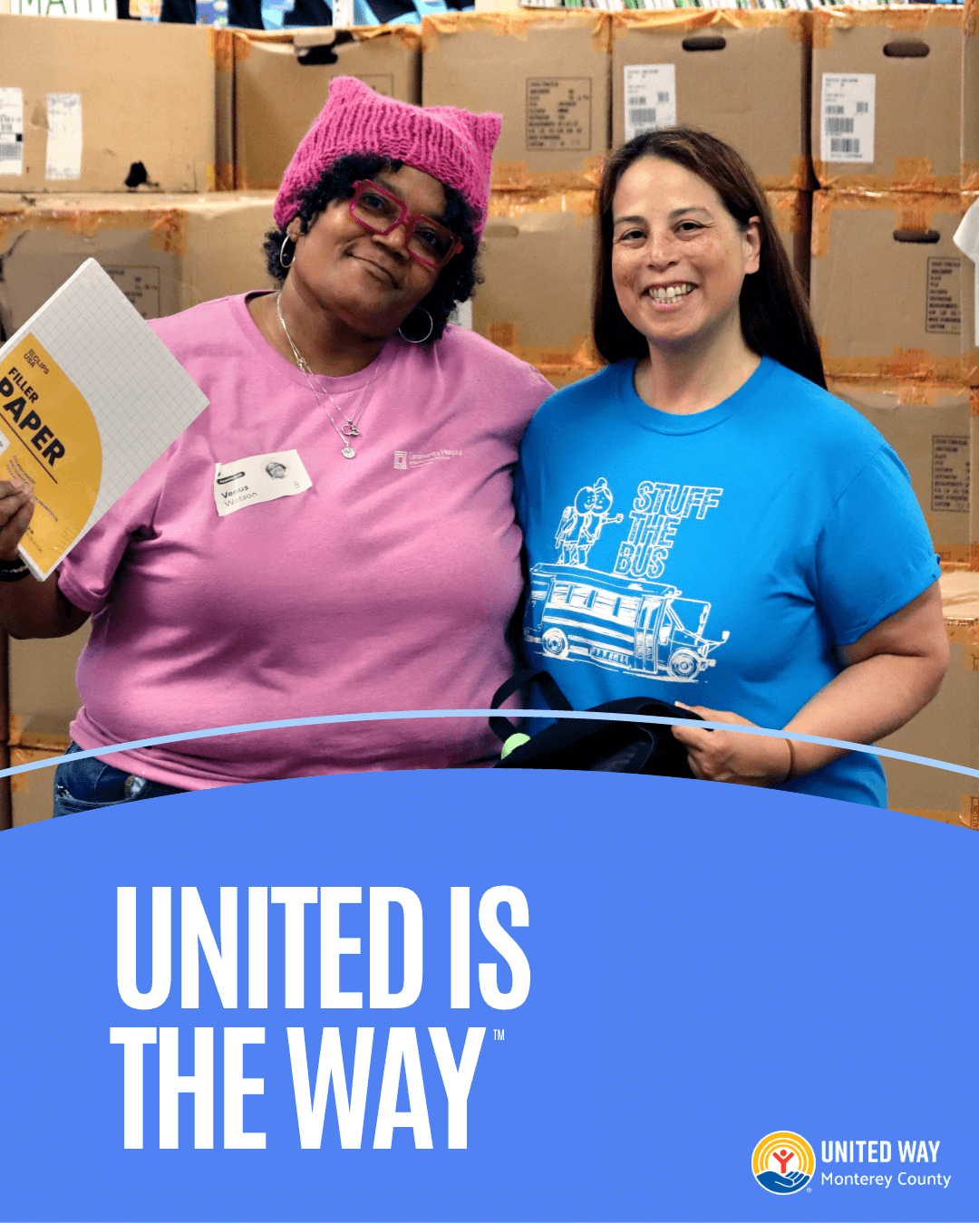

IMPORTANT CAMPAIGN LINKS
- Find Your Organizations Donation Webpage
- Social Media Canva Template
- United Way Videos
- FAQs

